William Chen

**Onboarding project**

2020-2021

**William Chen**



William Chen is a junior pursuing a BS in Information Management and Technology at the iSchool. Originally from NYC, William is chasing his dream of being in IT by concentrating on security. It’s important for him to understand security to protect everyone’s data. During his free time, he enjoys playing video games, basketball, and watching movies.

PricewaterhouseCoopers (PwC) is one of the big four accounting firms that focus on auditing, assurance, tax, and consulting services for other businesses. PwC’s purpose is to build trust in society and solve important problems and their values “define the expectations we have for working with each other and our clients.” PwC strives to achieve greatness and resolve problems. They act with integrity and stand by the work they do. Jacqueline Rubino, the talent acquisition manager at PwC in the New York Metro area, has been working at PwC for about nine years. Rubino started as an asset management operations project team specialist. As she continued to work for PwC, she ended up working in HR. As a talent acquisition manager, Rubino is responsible for hiring and maintaining employees. She aims to make the workplace highly enjoyable among all employees and make necessary changes to retain those employees. When looking to hire people, she looks for the brightest, most talented, arduous individuals who are willing to learn and improve their work ethics.

# **Employer Analysis**

September 29, 2020

# **Letter of Application**

Jacqueline Rubino  
PricewaterhouseCoopers  
600 13th Street NW  
Washington, DC 20005

Re: TAX Innovation Tax Reporting and Strategy Intern

Dear Jacqueline Rubino,

I am writing to formally express my interest in the TAX Innovation Tax Reporting and Strategy Internship, found on pwc.com. This position is ideal for me because as a junior, it parallels both my interests in the company, and matches my qualifications in the responsibilities of the role. By being a part of this position, I am able to learn more about the company while developing my business acumen to help succeed in the business world. Coming from a background with many years in customer service, my motto also falls in line with PwC’s purpose: to build trust in society and solve important problems.

As a student manager at the Carrier Dome, I have been equipped with a diverse toolset that allows me to thrive in various business functions. During my time at the company, I have taken various leading roles, primarily in client-facing responsibilities. My experiences have included ensuring thousands of people get inside the Carrier Dome efficiently and smoothly without any hassles from the beginning of the event, to completion; as well as ensuring my team is working diligently and in a professional manner to ensure a pleasant experience while clients are staying in the Carrier Dome. I understand the challenges that arise from extensive assignments, and I will be a valuable asset to any team taking on projects.

My previous experience in my parent’s restaurant also helped developed my consumer first approach. I was able build a rapport with recurring customers which made them feel valued. I have been successful in an intensive environment that has required endurance, determination, and dedication. These traits have come to fruition through job tasks such as taking a leading role in coordinating teams. My involvement in these businesses has left me confident in my abilities to excel in a new setting, and eager to utilize my abilities, especially in the internship. Furthermore, as a young student, I am always eager to improve my skillset. PricewaterhouseCoopers can help me in this venture, as I continue to learn and improve my data and analytics skills.

I am eager to participate as a Tax Reporting and Strategy Intern, and look forward to discussing my candidacy further in person. Please feel free to contact me by phone or email if any clarifications about my qualifications are necessary. I will be glad to answer any and all questions. Thank you for your time and consideration.

Sincerely,

William Chen  
[wchen67@syr.edu](mailto:wchen67@syr.edu)  
(917) 396-9498

October 3rd, 2020

# **Letter of Recommendation**

William Chen

PricewaterhouseCoopers LLP

300 Madison Ave, New York, NY 10017

[(646) 471-3000](https://www.google.com/search?q=pwc%20nyc&rlz=1C1CHBF_enUS915US915&oq=pwc+nyc&aqs=chrome.0.69i59j0l2j46l2j69i60l3.663j0j7&sourceid=chrome&ie=UTF-8&sxsrf=ALeKk011ovJRzbMhViYMuckoTKXn39gY7w:1601755942975&npsic=0&rflfq=1&rlha=0&rllag=40734392,-74007055,3109&tbm=lcl&rldimm=10204622448355857673&lqi=Cgdwd2MgbnljIgOIAQFaDgoDcHdjIgdwd2Mgbnlj&ved=2ahUKEwjso_3vnZnsAhULh-AKHSzXCGYQvS4wAHoECBAQIA&rldoc=1&tbs=lrf:!1m4!1u3!2m2!3m1!1e1!1m4!1u16!2m2!16m1!1e1!1m4!1u16!2m2!16m1!1e2!1m5!1u15!2m2!15m1!1shas_1wheelchair_1accessible_1entrance!4e2!2m1!1e16!2m1!1e3!3sIAE,lf:1,lf_ui:4&rlst=f)

Wchen67@syr.edu

Rich Ferriggi

Professional Physical Therapy

66 Commack Road

Commack, NY 11725

Dear Mr. Ferriggi,

I am writing to you regarding Ben Wichman, who has applied for your company's intern position. Although Ben doesn’t work in my department, our company hired him due to his extensive experience as an intern in his previous years.

Ben Wichman is currently a junior at Syracuse University, majoring in health & exercise science. Accordingly, Ben is interested in expanding his knowledge to find opportunities and become a physical therapist. He grasped the concepts of his department quickly and learned about all of the services. His passion for his role and his outstanding leadership abilities made him a worthy asset to the organization. Ben is continually working towards his goal to become a physical therapist by helping peers during stressful times. Ben is organized, and his positive attitude and optimism made him popular among clients and his colleagues.

I believe Ben will offer the business new ideas and potential investments that will benefit everyone. Ben has held three different internships within the physical therapy field; two in physical therapy clinics and one that he currently holds as a part of the training staff at Syracuse University. In his current position, Ben works alongside the football athletic trainers and ensures players are properly hydrated. His job is to make sure the players won’t faint or get injured and, if they do, to ensure they receive the proper treatments for a speedy recovery. In his previous internships, Ben learned the different types of treatments that other physical therapists use. Things like these make Ben interested in becoming a physical therapist, and the internship is one step closer to that dream.

Aside from his outstanding professional achievements, Ben is a delight to work with. No matter the situation, Ben is a pleasure to work with. He tries and succeeds in keeping people happy and optimistic in their projects. He is committed to working his way up to become a physical therapist and will give it his all.

Thank you for your time, and I hope this helps in making your decision. Should you have any questions, please don’t hesitate to reach out, and I will gladly answer any questions or concerns you have.

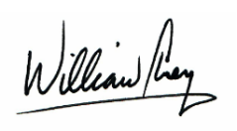Sincerely,

William Chen

# **Memorandum**

**To** Rich Ferriggi

**From** William Chen

**Date** October 3, 2020

**Subject** Recommendation for Ben Wichman for Internship

I am writing to you today to recommend Ben Wichman for the intern position at Professional

Physical Therapy.

**Background**

Ben is devoted to working hard to become a physical therapist and has many years of experience to

back it. He held three different internships to expand his knowledge and work experience. In his

current position, he assists Syracuse University’s football training staff to ensure the student-athletes

stay properly hydrated and healthy. Prior to this, he interned alongside other physical therapists to

learn different treatment methods. As a longtime colleague of Ben, I’ve had the opportunity to see

him execute his experience and knowledge in the office. He pushes everyone to do their best and

stay optimistic. Ben’s passion in this field pushed him to work hard and achieve what he has today.

At PwC, Ben has helped employees and clients stay positive and optimistic during stressful situations.

He gained a vast amount of knowledge and experience that places Ben far beyond others in his age group.

**Recommendation**

No one else comes to mind when it comes to being as dedicated as Ben is. He exemplifies all the traits

of a personal trainer and will do anything necessary to become one. Being a longtime colleague of Ben

has shown me how hard working and passionate he is about what he does and learns. If you have any

questions or concerns, please don’t hesitate to email me at [wchen67@syr.edu](mailto:wchen67@syr.edu) or call me at

917-396-9498. Thank you for your time and consideration. I hope this helps in making your decision

for the intern position.



To: Rich Ferriggi

# **Email**

CC: Ben Wichman

Subject: Recommendation for Internship at Professional Physical Therapy

Good afternoon Rich,

I highly recommend Ben Wichman for the internship position available at Professional Physical Therapy. I strongly recommend him for this position and believe he is the ideal candidate given his extensive work experience.

As a colleague, Ben has inspired me to take care of myself and others. He brings positivity to the most stressful situations and makes people believe in themselves. This is an exceptional quality he can bring to Professional Physical Therapy. Many people go to Professional Physical Therapy seeking help with body problems; and lots of times, the clients are in pain, hoping the issues can be resolved. Ben’s positive influence will assure clients with optimism and positivity, which helps maintain a calm environment. Additionally, Ben held multiple internships throughout the years to improve his physical therapy practices and is working towards becoming a physical therapist.

As young as Ben is, he has extensive knowledge of physical therapy activities and experience. I hope you consider my recommendation as further assurance that Ben is the person for the internship. Thank you for your time, and please don’t hesitate to reach out if you have any questions of concerns!

Best regards,

William Chen

PricewaterhouseCoopers

New York, NY

[Wchen67@syr.edu](mailto:Wchen67@syr.edu) | (917) 396-9498

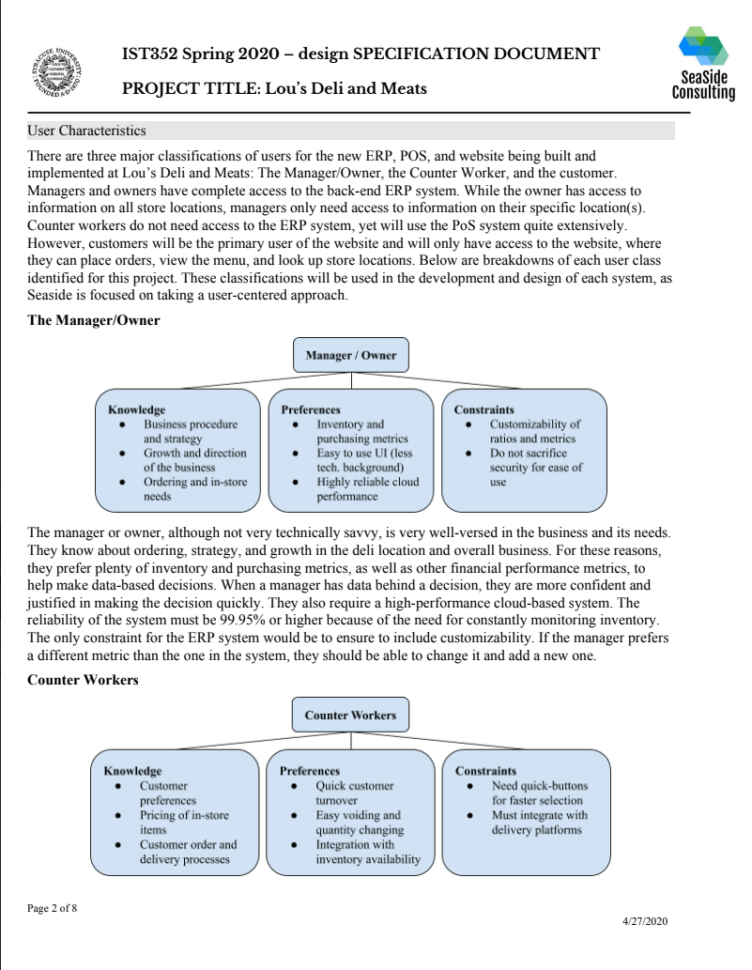

# **Text-Based Genre**

For this assignment, we posed as a consulting company that designed an information system. This assignment resulted in 48 pages total.

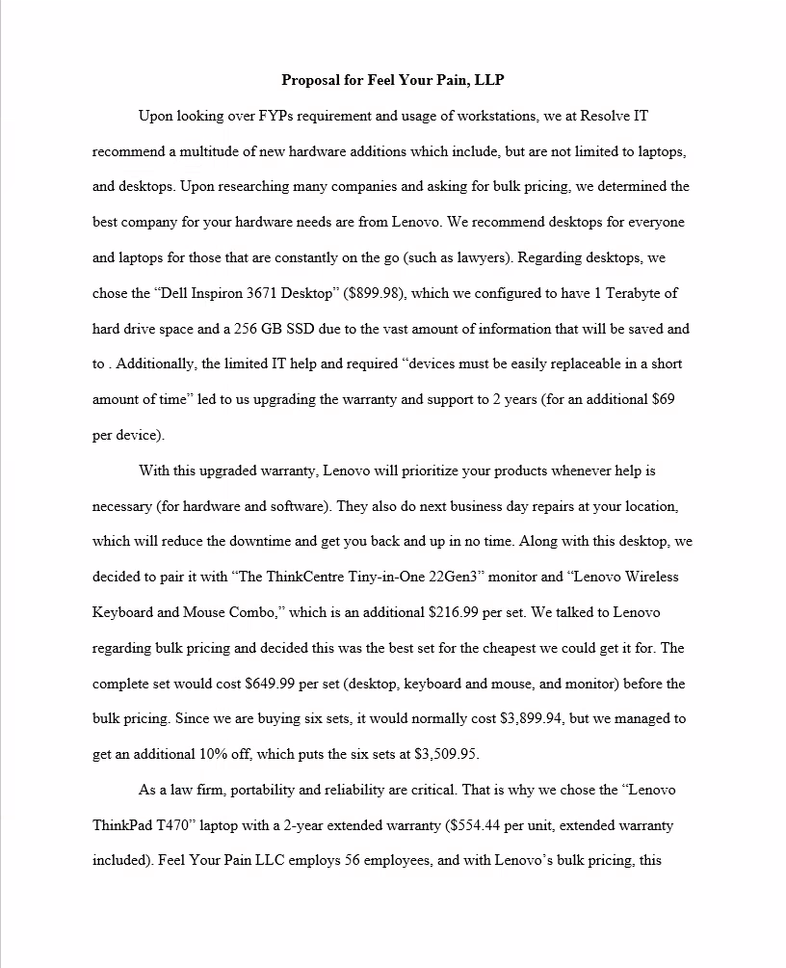

# **Text-Based Genre (continued)**

For this assignment, I posed as an organization that provided technological suggestions. This assignment totaled eight pages.

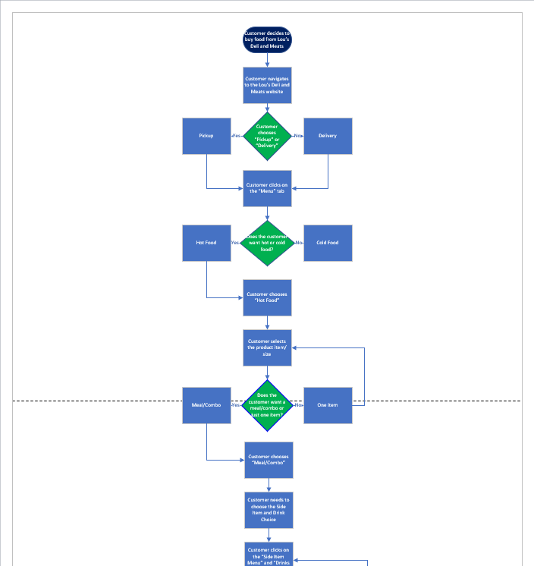

For this assignment, we created a flowchart for our company’s product. This flow chart continued for eleven pages.

# **Non-Text Based Genre**